Christmas Eve Service

Christmas Eve Service

**Welcome and Prayer**

**Advent Candle Lighting**

*#28 I AM SO GLAD EACH CHRISTMAS EVE, VERSES 1-2*

*#18 JOY TO THE WORLD*

**Scripture Reading Bolluyt Family** *Luke 2:1-20, p. 1090*

*#26 WHAT CHILD IS THIS*

**Meditation**

*#36 INFANT HOLY, INFANT LOWLY*

**Dramatic Reading**

Adapted from *Because of Bethlehem* by Max Lucado

**Special Music Elise Kramer**

**Candle-Lighting Service**

By order of the State Fire Marshall, only those 15 years of age or older are allowed to use candles with a flame. Battery-powered candles are available for those under 15 years of age.

An usher will light the candles of the person sitting next to the aisle in each pew. Each person with an unlit candle will tip theirs to light it from the lit candle.

*#331 AWAY IN A MANGER*

*#23 SILENT NIGHT! HOLY NIGHT!*

**Welcome and Prayer**

**Advent Candle Lighting**

*#28 I AM SO GLAD EACH CHRISTMAS EVE, VERSES 1-2*

*#18 JOY TO THE WORLD*

**Scripture Reading Bolluyt Family** *Luke 2:1-20, p. 1090*

*#26 WHAT CHILD IS THIS*

**Meditation**

*#36 INFANT HOLY, INFANT LOWLY*

**Dramatic Reading**

Adapted from *Because of Bethlehem* by Max Lucado

**Special Music Elise Kramer**

**Candle-Lighting Service**

By order of the State Fire Marshall, only those 15 years of age or older are allowed to use candles with a flame. Battery-powered candles are available for those under 15 years of age.

An usher will light the candles of the person sitting next to the aisle in each pew. Each person with an unlit candle will tip theirs to light it from the lit candle.

*#331 AWAY IN A MANGER*

*#23 SILENT NIGHT! HOLY NIGHT!*

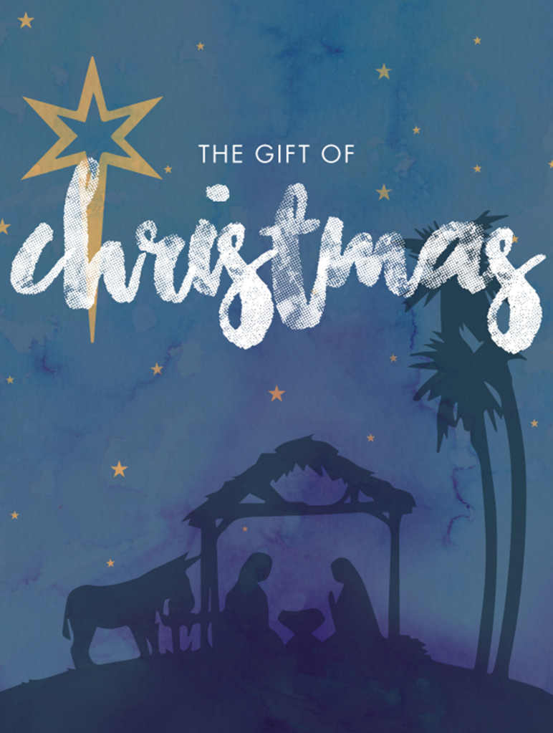

CALVARY FREE LUTHERAN CHURCH

Association of Free Lutheran Congregations (AFLC)

1416 County Highway 111 Fergus Falls, MN 56537

*The purpose of Calvary Free Lutheran Church is to proclaim and live the Gospel of Jesus Christ in a way that will impact our families, our community, and the world to the glory of God.*

WELCOME to CALVARY

WELCOME to CALVARY

CALVARY FREE LUTHERAN CHURCH

Association of Free Lutheran Congregations (AFLC)

1416 County Highway 111 Fergus Falls, MN 56537

*The purpose of Calvary Free Lutheran Church is to proclaim and live the Gospel of Jesus Christ in a way that will impact our families, our community, and the world to the glory of God.*