**Let’s Go-Let’s Grow: A series on growing in your Faith**

**Growing As a Disciple**

*Luke 14:25-33, p. 1111*

Pastor Eric Rasmussen | February 12, 2023

1. Jesus calls me to H_____________ other people and other things?
2. Jesus calls me to H_______________ myself?
3. Jesus calls me to bear my own C_______________.
4. Jesus calls me to count the C________________.
5. Jesus calls me to R_________________ all that I have.

***WELCOME***

*If you’re new to Calvary, please stop by the Welcome Center in the lobby. We would love to meet you and give you a small gift.*

***We are so glad you’re here!***

February 12, 2023

**Welcome and Announcements**

*BEHOLD OUR GOD*

*BEFORE THE THRONE OF GOD ABOVE*

**Confession of Sin**

*GOD YOU’RE SO GOOD*

**Scripture Reading**

*Mark 10:17-22, p. 1076*

**Confession of Faith**

*Apostles’ Creed*

**Congregational Prayer**

**Special Music** Ruby Kleinschmidt

**Sermon**

*#485 ALL TO JESUS I SURRENDER*

**The Lord’s Prayer**

**Benediction**

**Threefold Amen**

***THIS WEEK AT CALVARY***

**Today, 2/12**

11:45 Deaconess Meeting in the Fellowship Hall

5 PM Superbowl Party

**Tuesday, 2/14**

**Valentine’s day**

9:30 AM Kyria Bible Study

**Wednesday, 2/15**

2 & 7 PM Adult Bible Study

3:45 PM Kids Club

7 PM CSM

**Friday, 2/17**

7:30 AM Men’s Prayer Breakfast

**Sunday, 2/19**

8:45 AM Prayer Time

9:15 AM Sunday School

10 AM Coffee Connection

10:30 AM Worship Service & Livestream

***Calvary Contact Information:***

Church Office

calvaryfreelc@gmail.com

218.736.4282

calvaryfergusfalls.org

Jim Johnson, Senior Pastor

jimjohnson9359@gmail.com

Cell: 218.770.0693

Eric Rasmussen, Associate Pastor

rasmussen64@yahoo.com

Cell: 218.770.4161

*A staffed nursery room is available throughout the service for families who may need it (past the kitchen on the north end of the building).*

*We have assisted hearing devices for the hearing impaired. Please inquire*

*at the sound booth in the back of the sanctuary. Audio recordings of the*

*sermons are available at calvaryfergusfalls.org*



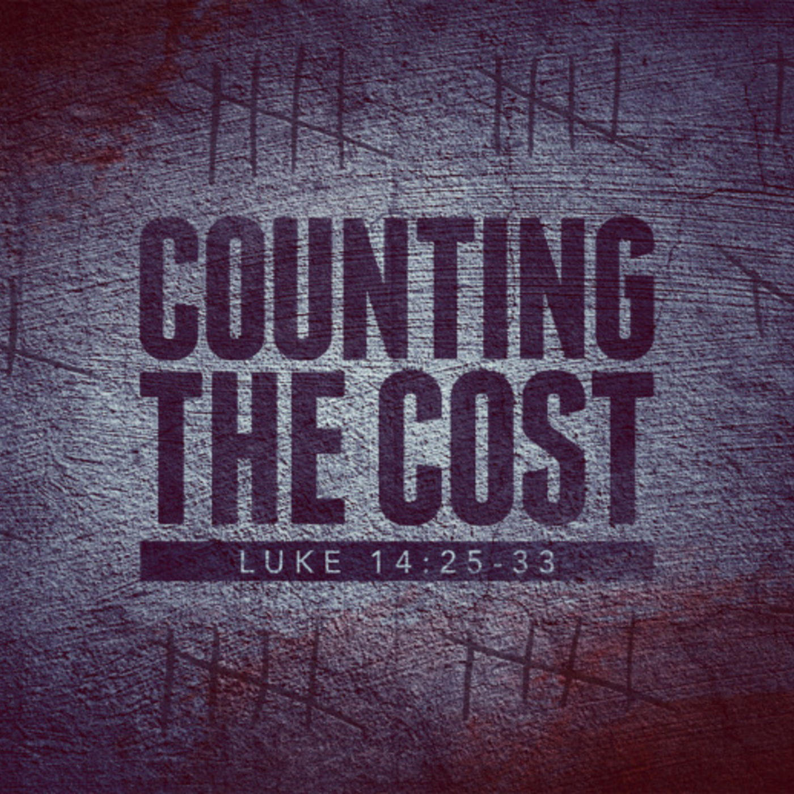

**SuperBowl Gathering today**

Everyone is invited to watch the big game at Church this evening. The party starts at 5pm. Bring a pizza, appetizer, snack, or dessert to share and your own beverage. Door prizes for the best jersey (any team) and the best Chiefs fan outfit and the best Eagles fan outfit.

**Cup of Prayer**

Ladies, we hope you will join in WMF’s Cup of Prayer. Bring a mug (with your name and prayer requests written on a note, tucked inside) and set it on the table in the narthex by Feb 19. Take someone else's mug and commit to praying for that woman for during Lent. At the end of Lent, return the mug to the table and take yours home.

**WMF Officers**

WMF is working to finalize our booklet for 2023. If you are wanting to be removed from a current position or committee, please let Abby Crowser (218-770-8233) know by Feb. 19. Otherwise, positions will remain the same for the duration of the year. Thank you for your willingness to serve!

***PRAYER CONCERNS***

* Thank God for the wonder of love that we can experience within the Biblical marriage relationship and for the example and empowerment of the love of Jesus, who loved his bride, the church, to the point of giving up himself for her (Ephesians 5:25).
* Nation: Pray that the celebration of Valentine’s Day will remind people of God’s design for love within marriage between a husband and wife based on Christ’s love for the church and turn people back to the truth.
* Pray for Gary Shelton, scheduled for heart bypass surgery on Monday.
* Home Missions: Pray for Pastor Matthew Pillman and his family, continuing a yearlong residency at Trinity Church in San Antonio, TX as they prepare to begin a church plant in Ankeny, IA.
* World Missions: Michael Rokenbrodt serving in Uganda – pray for safety and wisdom as he supports the Ambassador Institute Bible training ministry.
* AFLC: Association Retreat Center (ARC), Kirk Rautio, Director
* Additional Requests:

*The purpose of Calvary Free Lutheran Church is to proclaim and live the Gospel of Jesus Christ in a way that will impact our families, our community, and the world to the glory of God.*

WELCOME to CALVARY

CALVARY FREE LUTHERAN CHURCH

Association of Free Lutheran Congregations (AFLC)

1416 County Highway 111 Fergus Falls, MN 56537

***OPPORTUNITIES***

***FOR GROWTH AND FELLOWSHIP***