**Preparing for the Passion (Lent)**

*Luke 18:31-34, p. 1116*

Pastor Jim Johnson | February 19, 2023

1. Jesus fulfilled God’s p_______
2. Going to J_________________
3. Everything would be a_____________________
4. Jesus’ s____________ actions
5. Incomprehensible s________________
6. Put to d__________
7. R_______ on the third day
8. The d_____________ situation

***WELCOME***

*If you’re new to Calvary, please stop by the Welcome Center in the lobby. We would love to meet you and give you a small gift.*

***We are so glad you’re here!***

February 19, 2023

**Welcome and Announcements**

*10,000 REASONS*

*CHRIST OUR HOPE IN LIFE AND DEATH*

**Confession of Sin**

*LET IT BE SAID OF US*

**Scripture Reading**

*Psalm 22:1-2, 12-18, p. 580*

**Congregational Prayer**

**Sermon**

*#61 O SACRED HEAD, NOW WOUNDED, v. 1-3*

**The Lord’s Prayer**

**Benediction**

**Threefold Amen**

***THIS WEEK AT CALVARY***

**Monday, 2/20**

**President’s Day**

9 AM Calvary Quilters

**Wednesday, 2/22**

3:45 PM Kids Club

6 PM Lenten Supper

7 PM CSM

7 PM Lenten Service

**Friday, 2/24**

7:30 AM Men’s Prayer Breakfast

**Sunday, 2/26**

8:45 AM Prayer Time

9:15 AM Sunday School

10 AM Coffee Connection

10:30 AM Worship Service & Livestream

***Calvary Contact Information:***

Church Office

calvaryfreelc@gmail.com

218.736.4282

calvaryfergusfalls.org

Jim Johnson, Senior Pastor

jimjohnson9359@gmail.com

Cell: 218.770.0693

Eric Rasmussen, Associate Pastor

rasmussen64@yahoo.com

Cell: 218.770.4161

*A staffed nursery room is available throughout the service for families who may need it (past the kitchen on the north end of the building).*

*We have assisted hearing devices for the hearing impaired. Please inquire*

*at the sound booth in the back of the sanctuary. Audio recordings of the*

*sermons are available at calvaryfergusfalls.org*



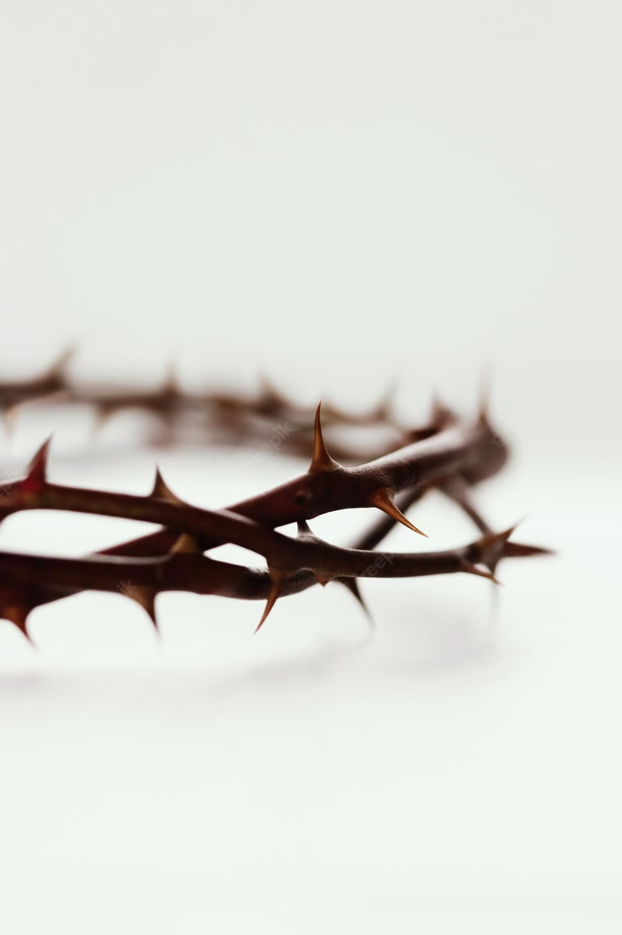

The Passover is coming, and the Son of Man will be delivered up to be crucified.

Matthew 26:2

***PRAYER CONCERNS***

* Give thanks that Jesus was willing to be “delivered over to the Gentiles… mocked… shamefully treated… spit upon”, flogged and killed for us. (Luke 18:32-33)
* Nation: As we observe President’s Day remember to pray for President Biden and his cabinet, for wisdom and righteousness, “that we may lead a peaceful and quiet life, godly and dignified in every way” (1 Timothy 2:2).
* Home Missions: Waikiki Beach Gathering, Pastor Brady Arneson – pray for their outreach event, the Backyard Beach BBQ, this Saturday.
* World Missions: John and Hannah Lee serving in Brazil – pray for John as he teaches some new classes at our seminary in Brazil and works on translating AFLC materials into Portuguese.
* AFLC: The Lutheran Ambassador magazine; Pastor Andrew Kneeland, Editor, Ruth Gunderson, Managing Editor
* Additional Requests:

**Cup of Prayer**

Ladies, we hope you will join in WMF’s Cup of Prayer. Bring a mug (with your name and prayer requests written on a note, tucked inside) and set it on the table in the narthex by Feb 19. Take someone else's mug and commit to praying for that woman for during Lent. At the end of Lent, return the mug to the table and take yours home.

**Lent 2023: Jesus Foreshadowed in the Tabernacle**

February 22 – Ash Wednesday: The Tabernacle

March 1 - The Altar of Sacrifice

March 8 - The Bronze Basin

March 15 - The Golden Lampstand

March 22 - The Table for Bread

March 29 - The Altar of Incense

April 7 – Good Friday: The Ark of the Covenant

A meal will be served at 6 PM February 22-March 29th. The service will begin at 7 PM each evening.

**Our Daily Bread**

The next quarter of Daily Bread devotionals are available on the Welcome Center or by the Mailboxes.

*The purpose of Calvary Free Lutheran Church is to proclaim and live the Gospel of Jesus Christ in a way that will impact our families, our community, and the world to the glory of God.*

WELCOME to CALVARY

CALVARY FREE LUTHERAN CHURCH

Association of Free Lutheran Congregations (AFLC)

1416 County Highway 111 Fergus Falls, MN 56537

***OPPORTUNITIES***

***FOR GROWTH AND FELLOWSHIP***